Challenge 1
Resolve Merge Conflicts
1. merge conflict error
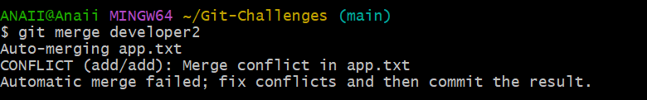
2.conflicted file
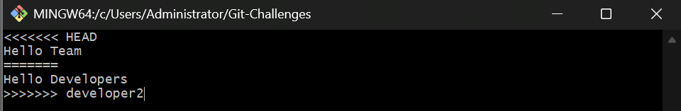
3. resolved file
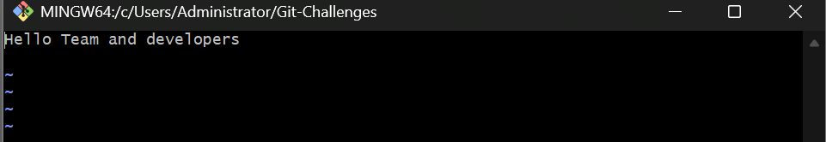
4. successful push
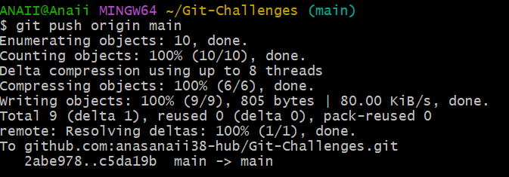

Challenge 2
Recover Deleted Branch
1. deleted branch
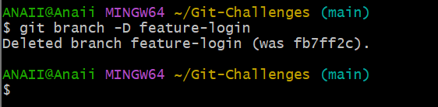
2. reflog
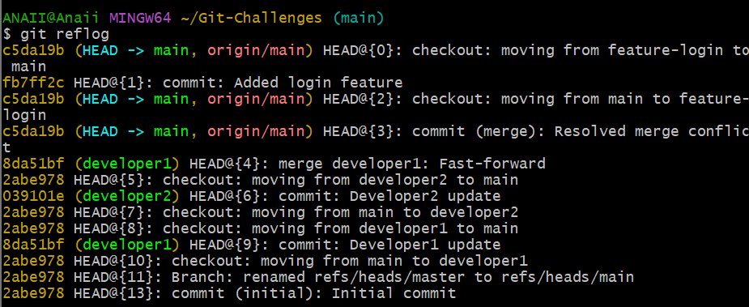
3. recovered branch
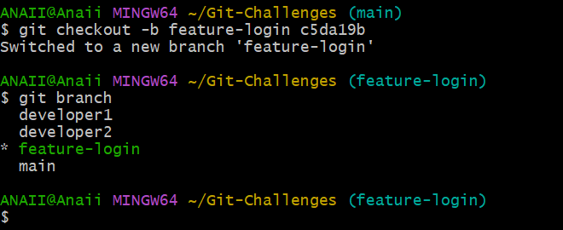

Challenge 3
Undo Wrong Push
1. wrong commit
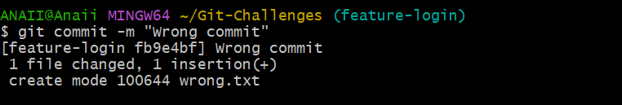
2. GitHub before revert
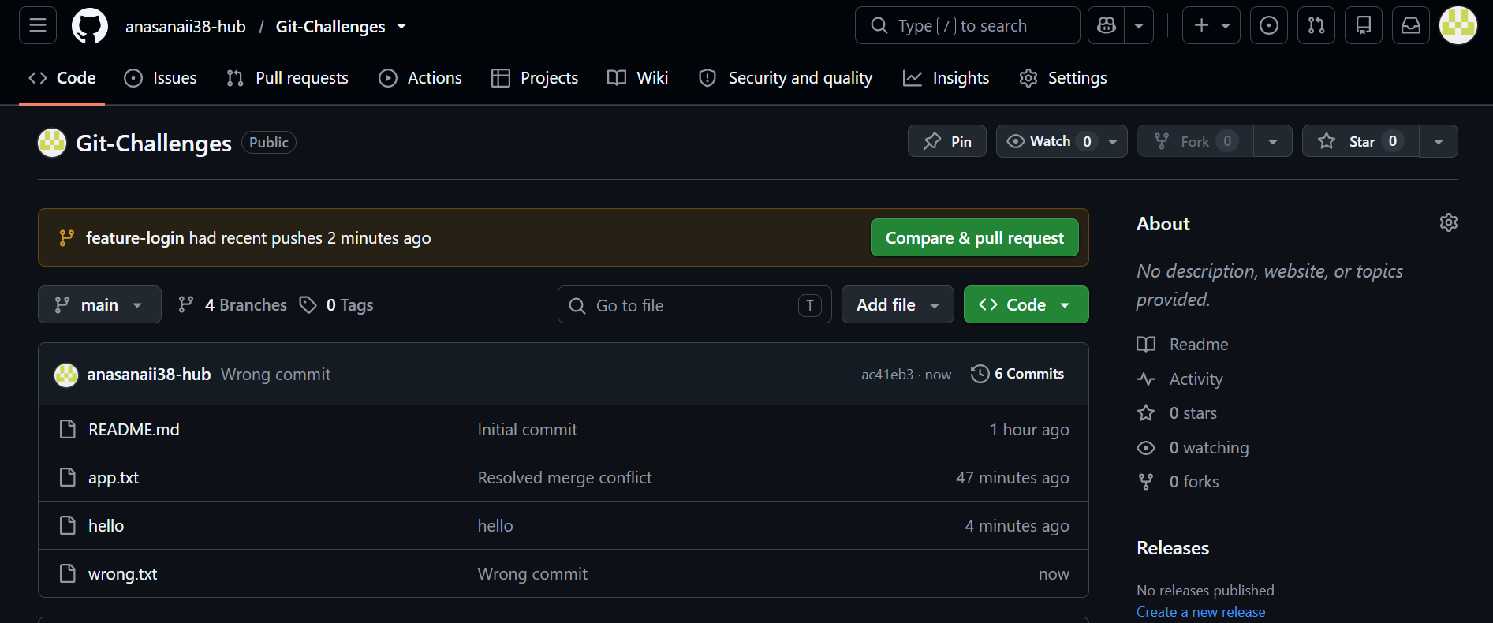
3. revert commit
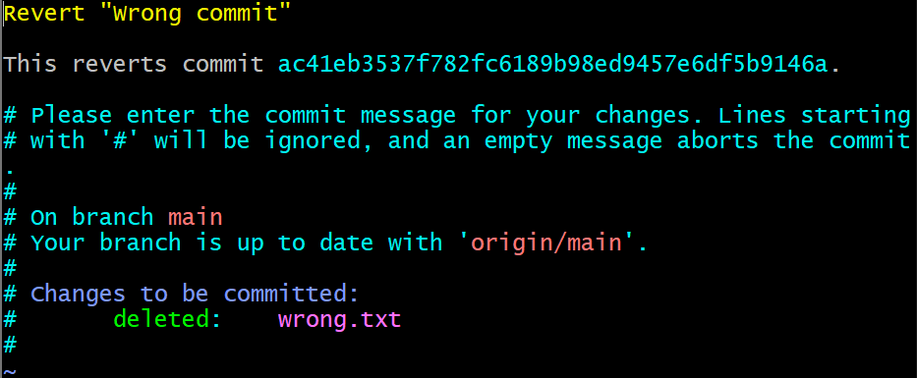

4. GitHub after revert
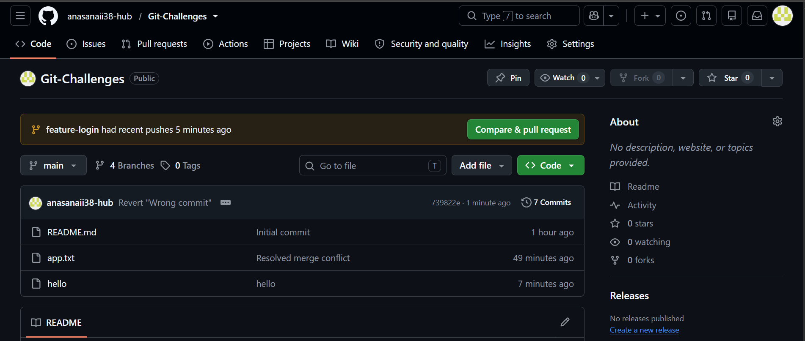

Challenge 4
Amend Commit
1. before amend
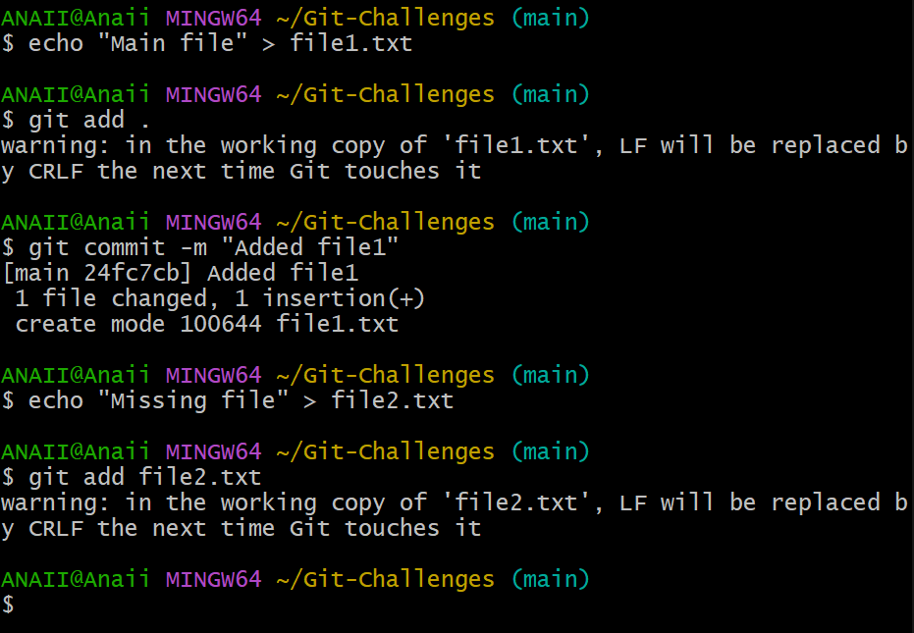
2. after amend
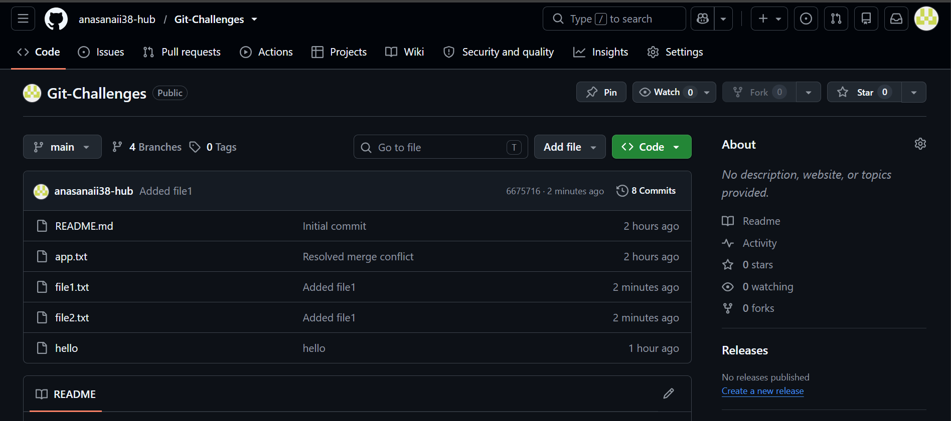
Challenge 5
Cherry Pick
1.in gitbash
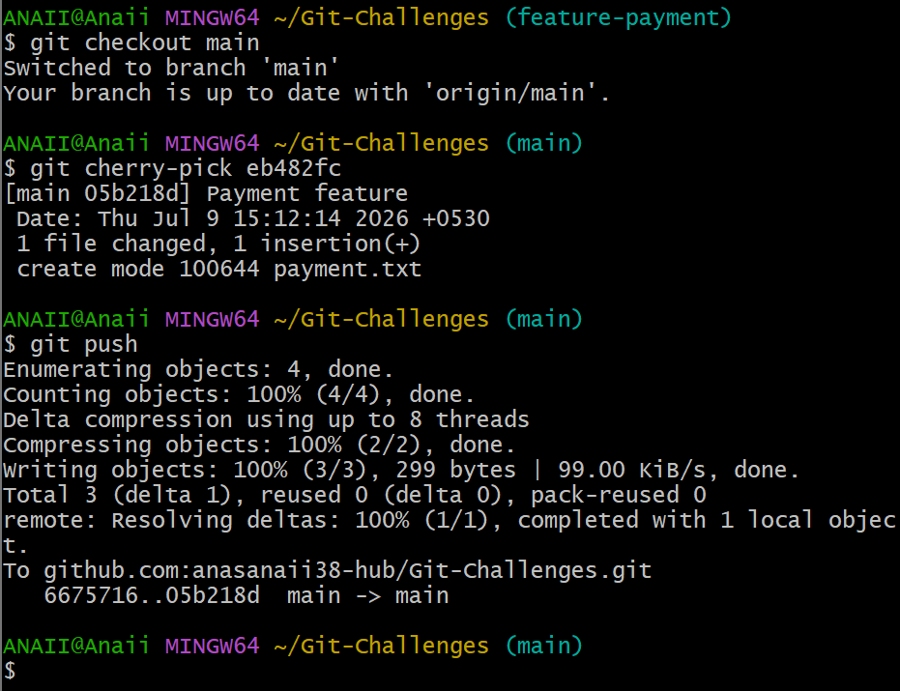
2. in github
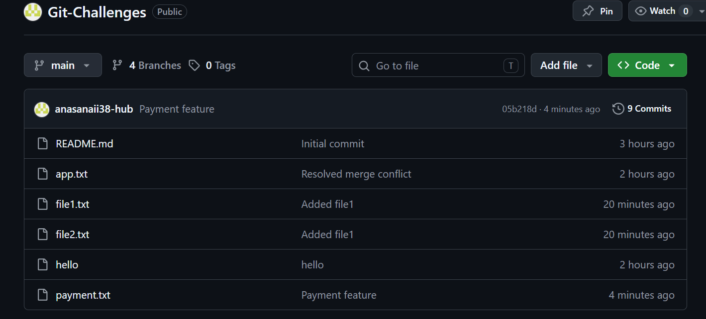

Challenge 6
Interactive Rebase
1.
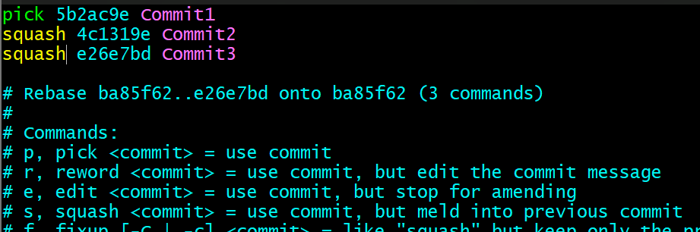
2.
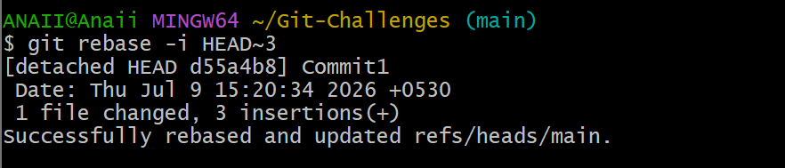
3.
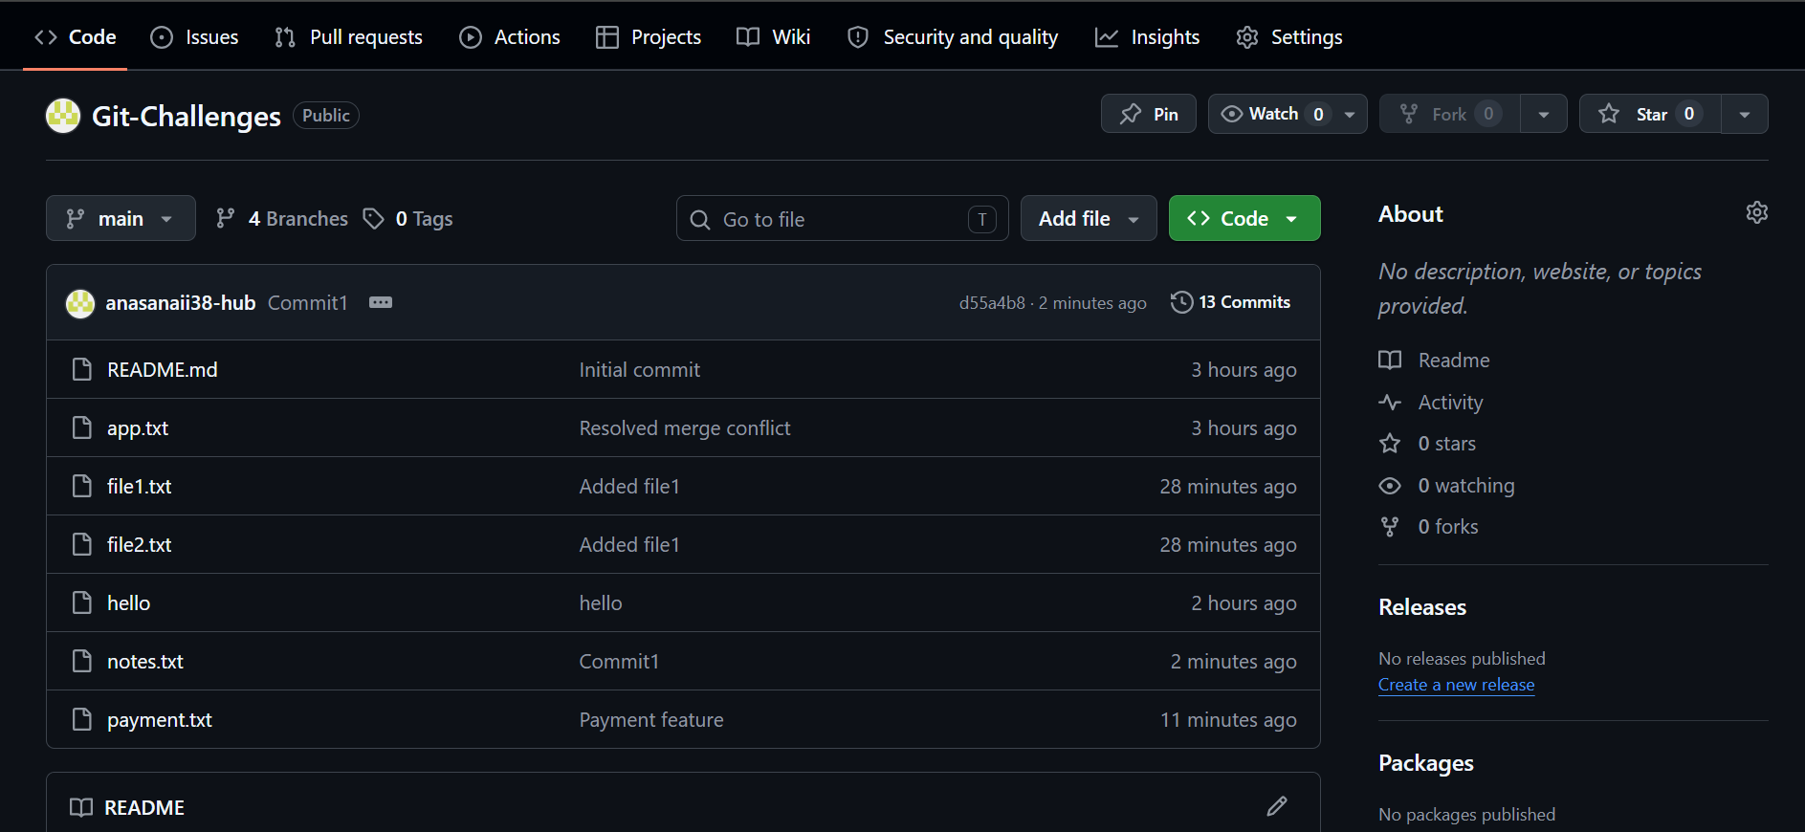

Challenge 7
Tagging
1. Deleted locally and remotely
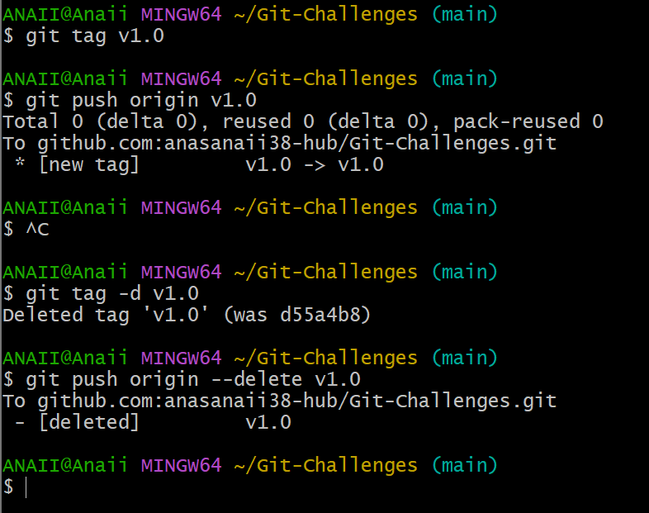
2. restored
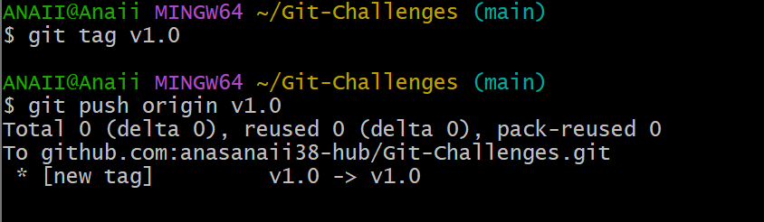

Challenge 8
Sparse Checkout
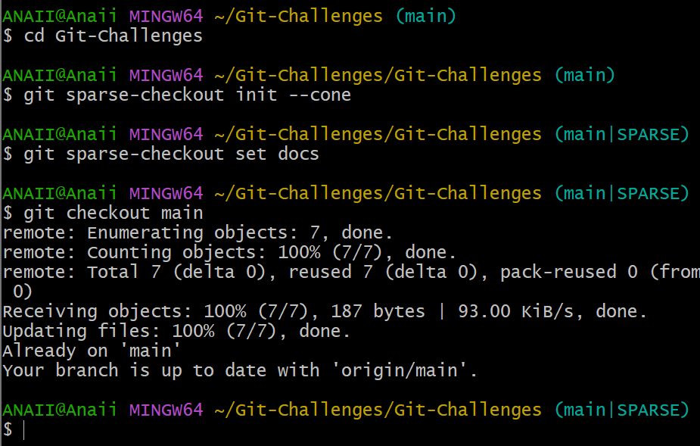

Challenge 9
Reset vs Revert
1. Reset
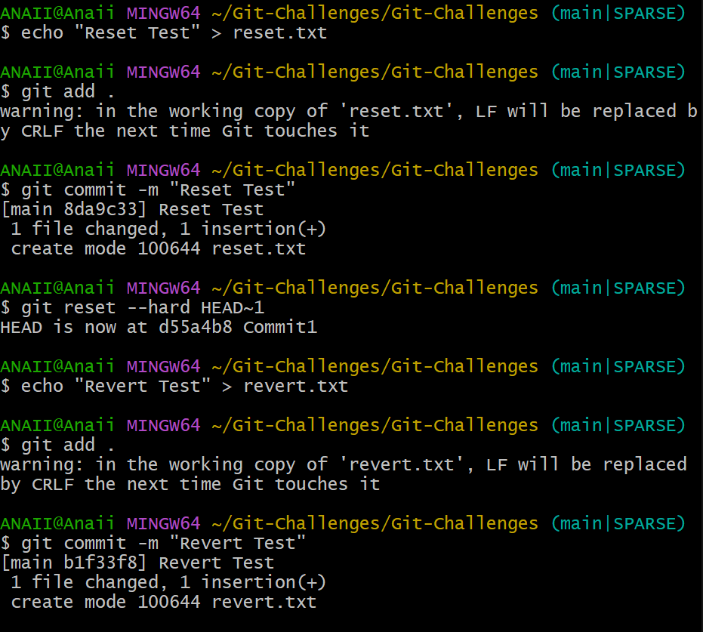
2. revert
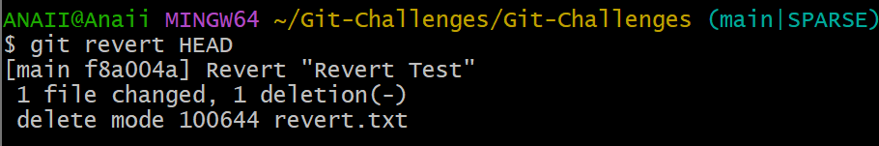
3. compare
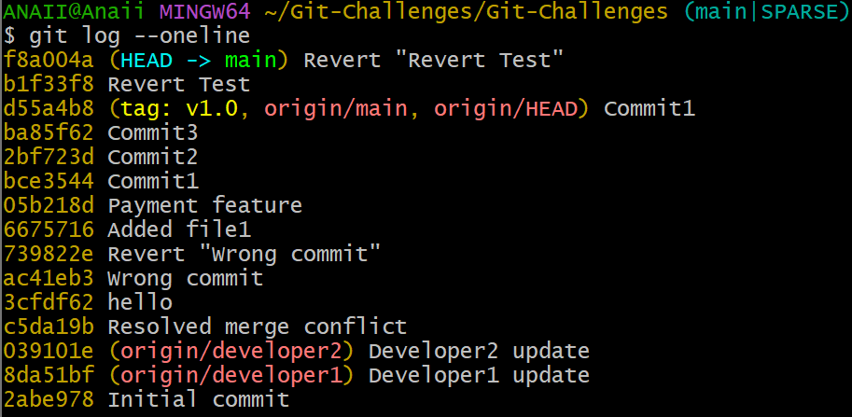
Challenge 10
Detached HEAD
1.Detached De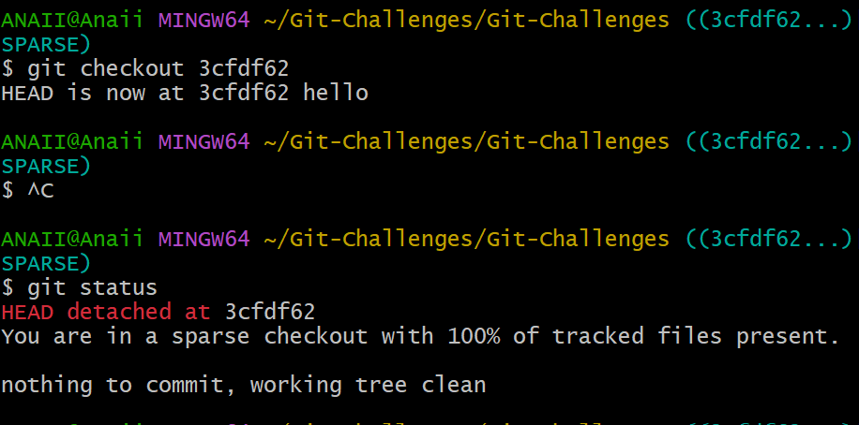
2. new branch
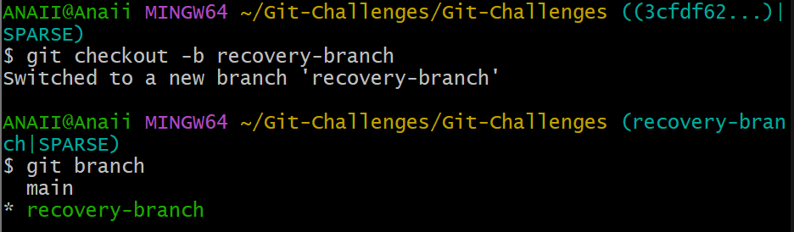

Challenge 11
Git Hook
1. Rejected commit
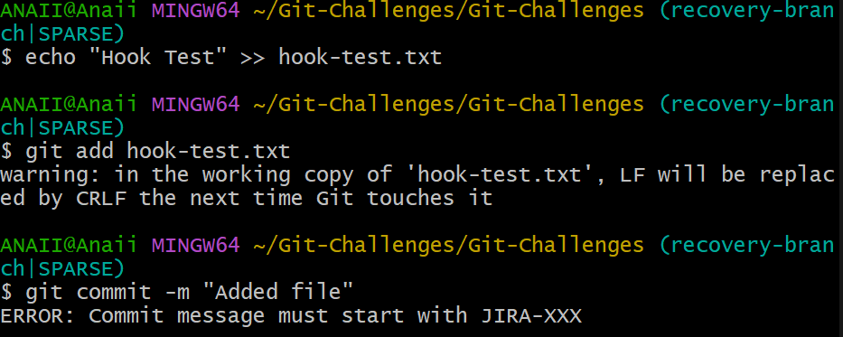
2. Sucessful commit
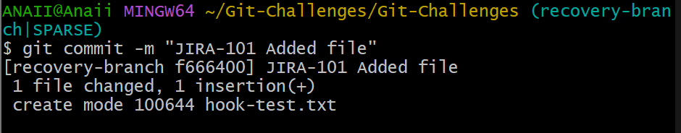

Challenge 12
Squash Merge vs Rebase Merge
1. Squash Merge
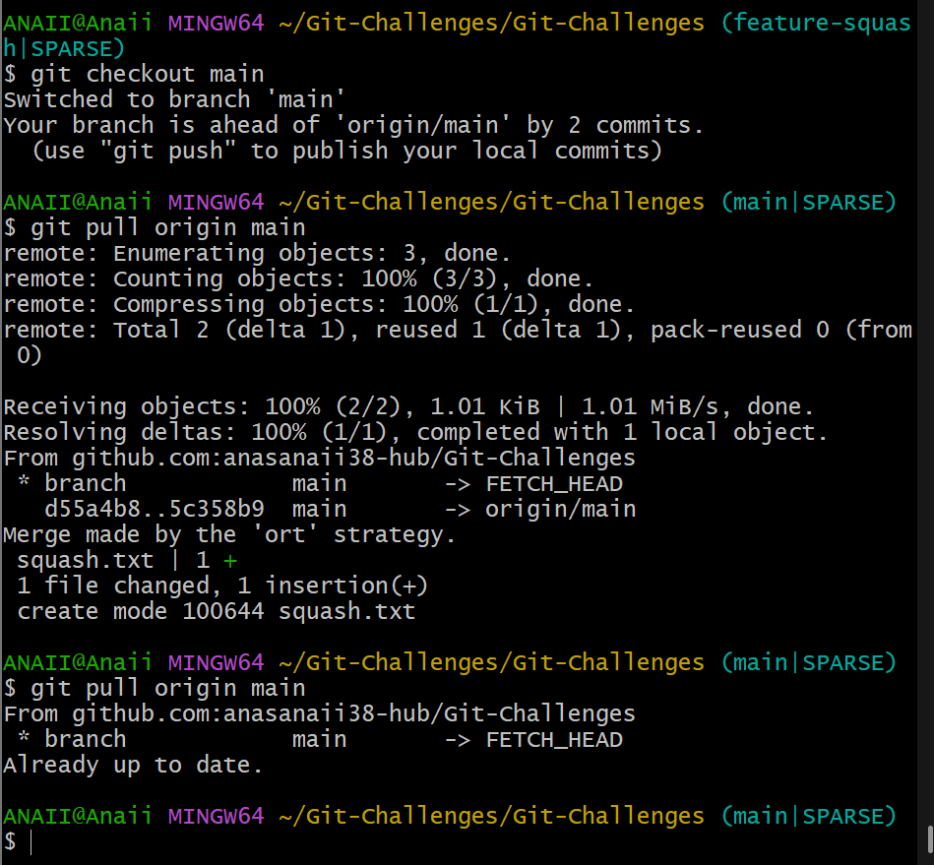
2. Rebase Merge
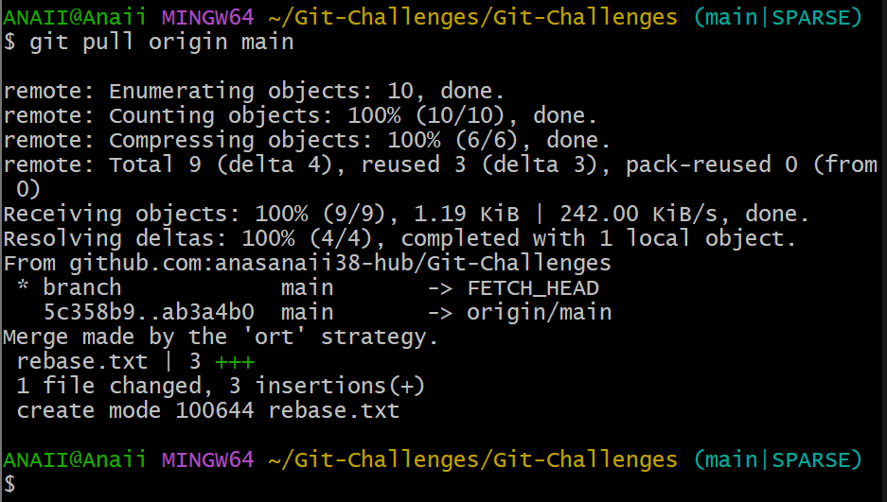
Challenge 13
Fork Workflow
Step 1: Fork the repository
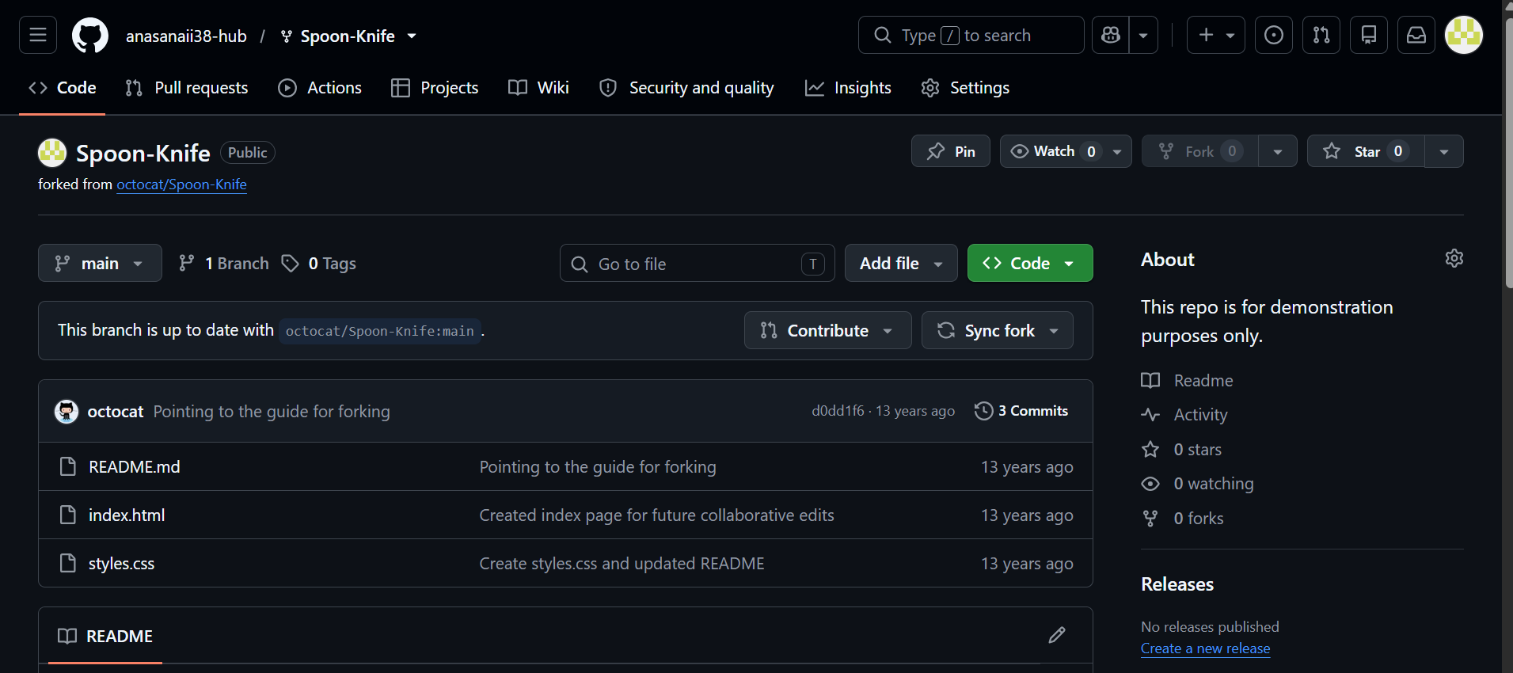
Step 2: Clone your fork
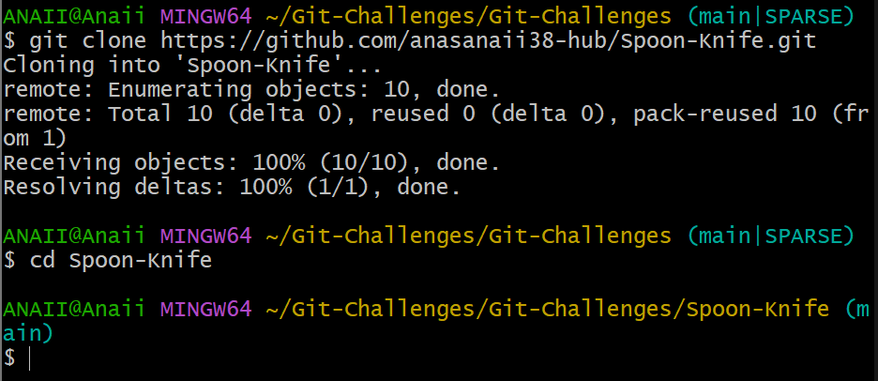

Step 3: Create a new branch
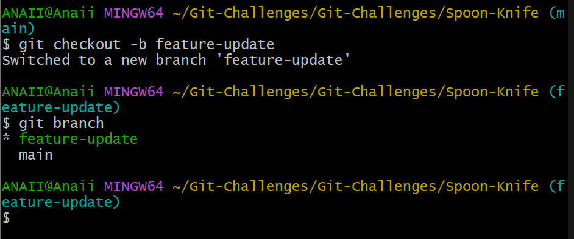
Step 4: Make a change
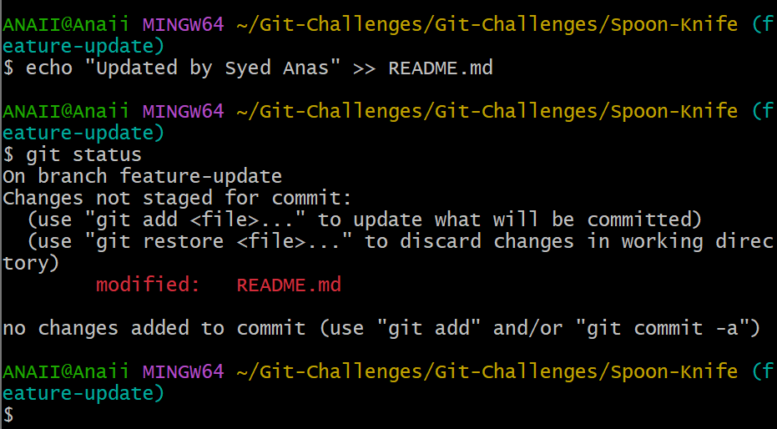

Step 5: Commit the change
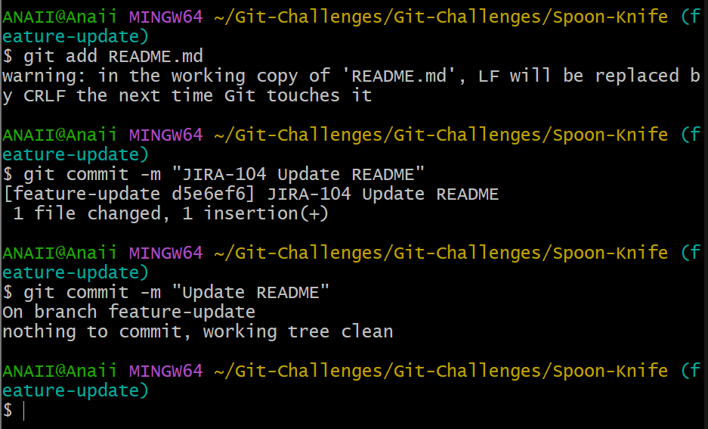
Step 6: Push the branch
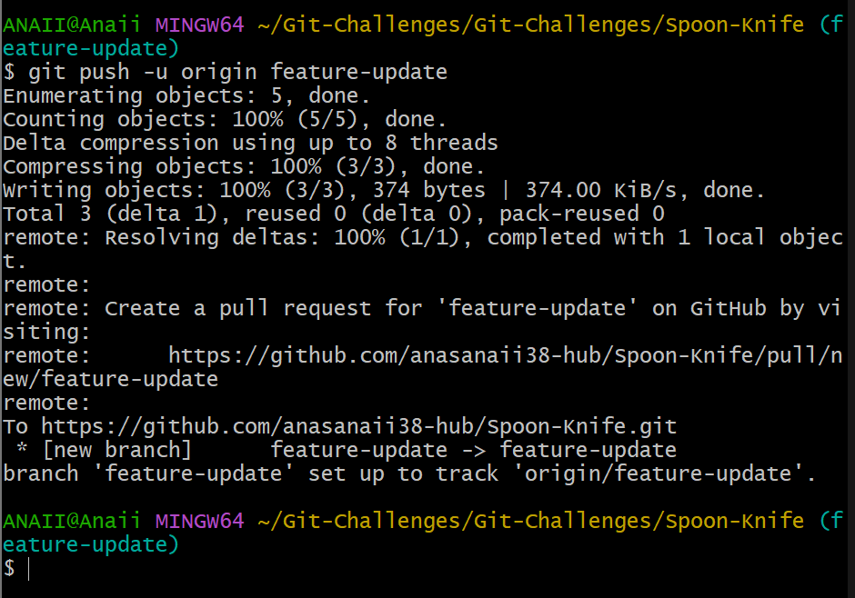

Step 7: Create the Pull Request
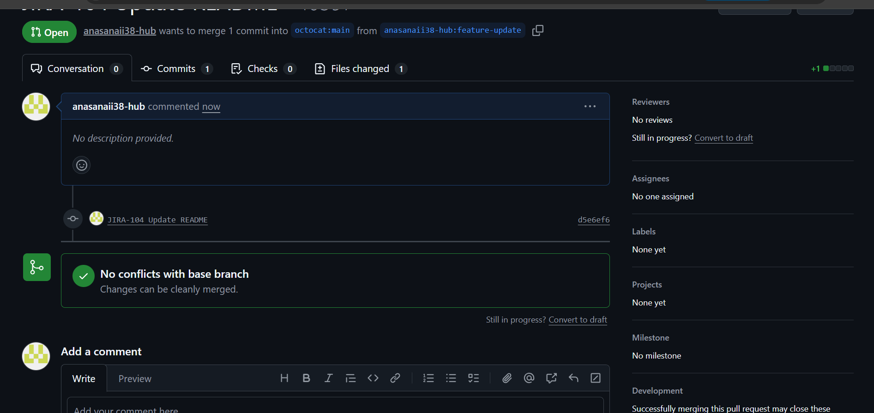
Step 8: Validation
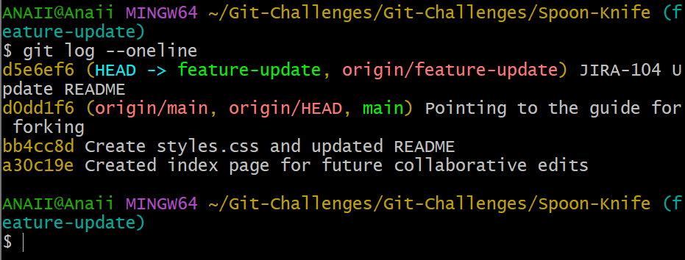

Challenge 14
Recover Lost Commit
1. reflog showing lost commit
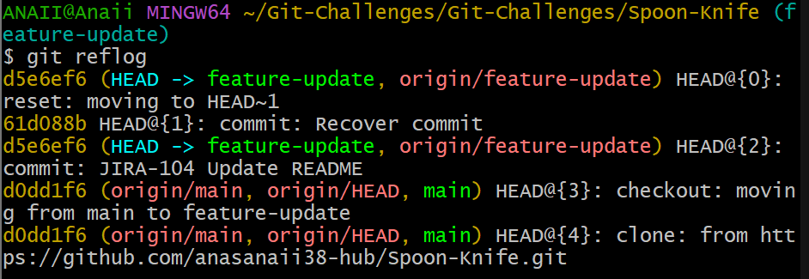
2. Recoverd
